**DAILY ONLINE ACTIVITIES SUMMARY**

|  |  |  |  |  |  |  |  |  |
| --- | --- | --- | --- | --- | --- | --- | --- | --- |
| **Date:** | **05/07/2020** | | | | | **Name:** | **Katira Krishna J** | |
| **Sem & Sec** | **8th A** | | | | | **USN:** | **4AL16CS045** | |
| **Online Test Summary** | | | | | | | | |
| **Subject** | | **-** | | | | | | |
| **Max. Marks** | | **-** | | **Score** | | | **-** | |
| **Certification Course Summary** | | | | | | | | |
| **Course** | **Data Science Methodology** | | | | | | | |
| **Certificate Provider** | | | **Cognitiveclass.ai** | | **Duration** | | | **5 hours** |
| **Coding Challenges** | | | | | | | | |
| **Problem Statement: Python program that takes string from the user and prints it using classes** | | | | | | | | |
| **Status: Completed** | | | | | | | | |
| **Uploaded the report in Github** | | | | | **Yes** | | | |
| **If yes Repository name** | | | | | **Krishna_Katira** | | | |
| **Uploaded the report in slack** | | | | | **Yes** | | | |

Online Test Details:

No test conducted

Certification Course Details:

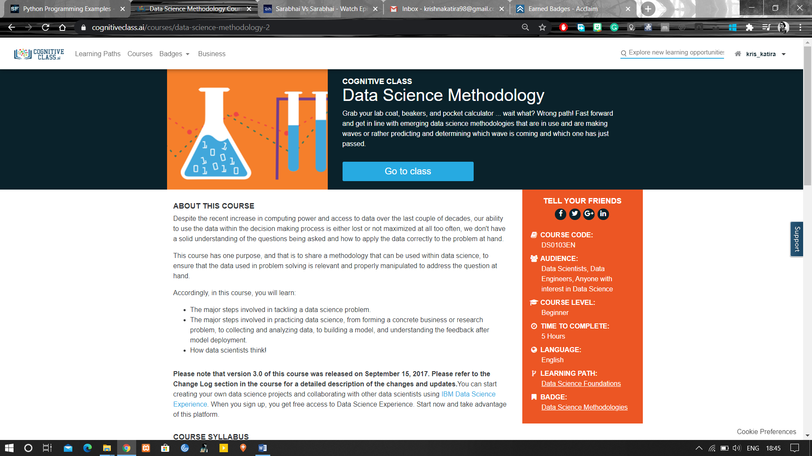

Coding Challenges Details:

**Program:**

class print1():

def __init__(self):

self.string=""

def get(self):

self.string=input("Enter string: ")

def put(self):

print("String is:")

print(self.string)

obj=print1()

obj.get()

obj.put()